School Name
Mathematics Test 2017
Year 10 |  | Factorisation | Calculator Allowed
Skills and Knowledge Assessed:  - Factorise algebraic expressions by taking out a common algebraic factor (ACMNA230)  - Apply the four operations to simple algebraic fractions with numerical denominators (ACMNA232)  - Expand binomial products and factorise monic quadratic expressions using a variety of strategies (ACMNA233)  - Extension - Factorise non-monic quadratic expressions |  |  | Name_________________
Section 1 Short Answer Section
Write all working and answers in the spaces provided on this test paper.

Factorise 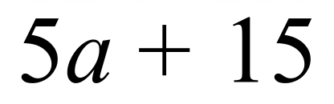.

……………………………………………………………………………………………….
Factorise 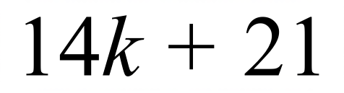.

……………………………………………………………………………………………….
Factorise 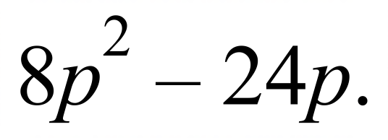

……………………………………………………………………………………………….
Factorise 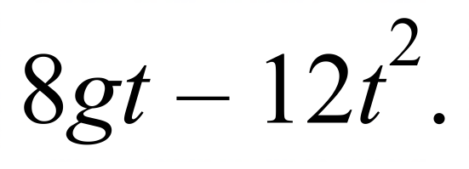

……………………………………………………………………………………………….
Factorise 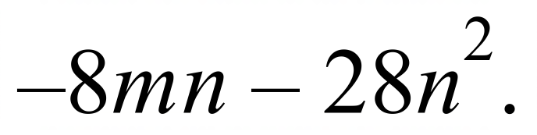

……………………………………………………………………………………………….
Factorise 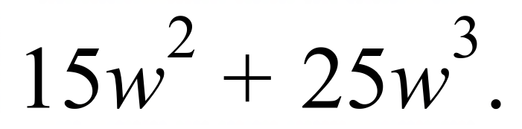

……………………………………………………………………………………………….
Factorise 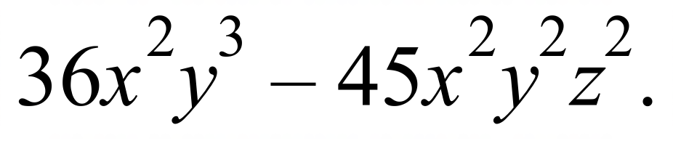

……………………………………………………………………………………………….
Factorise 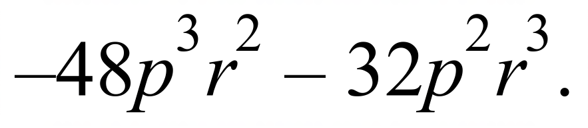

……………………………………………………………………………………………….
Factorise 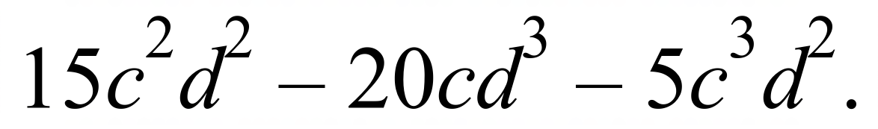

……………………………………………………………………………………………….
Factorise 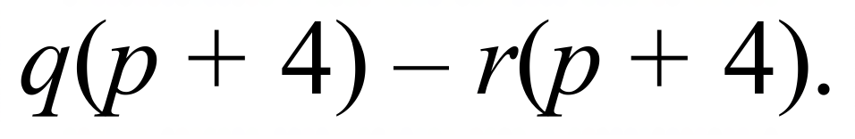

……………………………………………………………………………………………….
Factorise 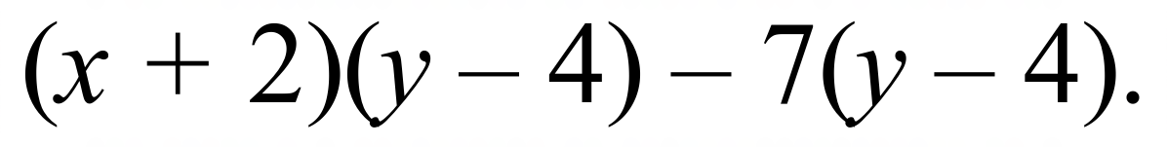

……………………………………………………………………………………………….
Factorise 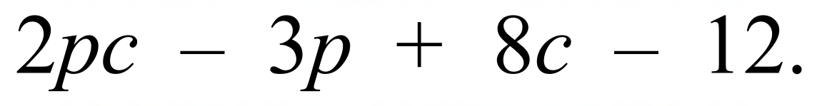

……………………………………………………………………………………………….
Factorise 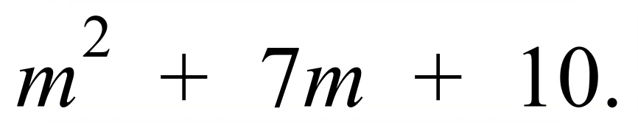

……………………………………………………………………………………………….
Factorise 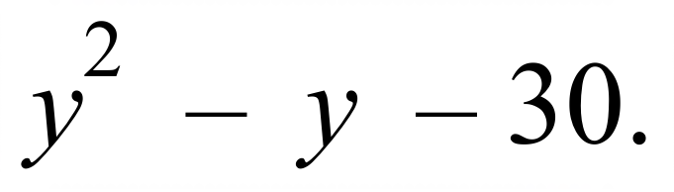

……………………………………………………………………………………………….
Factorise 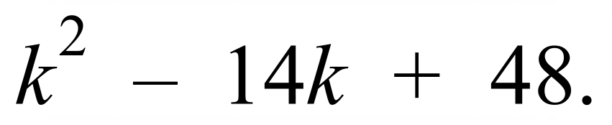

……………………………………………………………………………………………….
Factorise 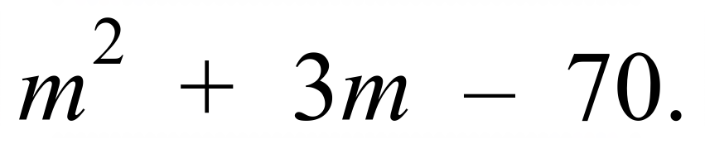

……………………………………………………………………………………………….
Factorise 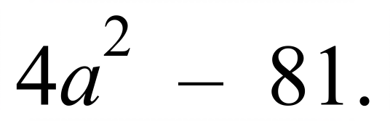

……………………………………………………………………………………………….
Factorise 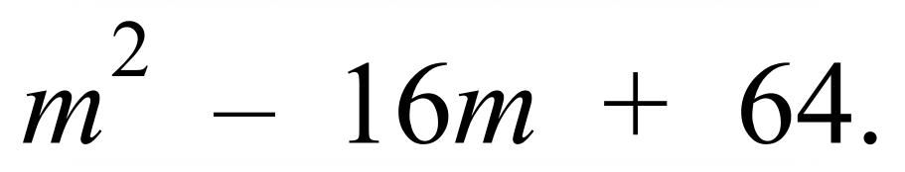

……………………………………………………………………………………………….
Factorise 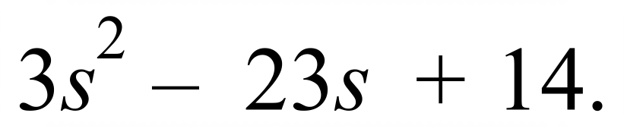

……………………………………………………………………………………………….

……………………………………………………………………………………………….
Factorise 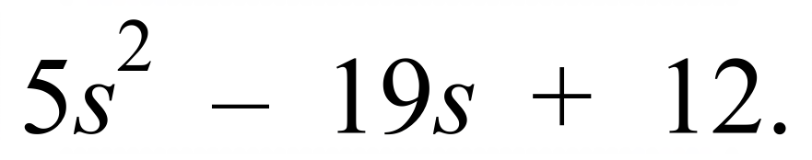

……………………………………………………………………………………………….

……………………………………………………………………………………………….
Factorise 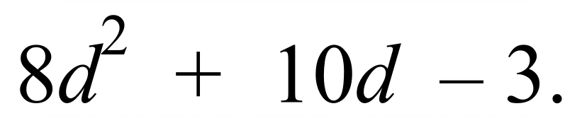

……………………………………………………………………………………………….

……………………………………………………………………………………………….

……………………………………………………………………………………………….
Factorise 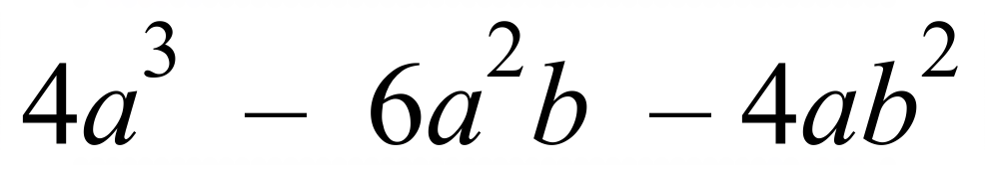 .

……………………………………………………………………………………………….

……………………………………………………………………………………………….

……………………………………………………………………………………………….

School Name
Mathematics Test 2017
Year 10 |  | Factorisation | Calculator Allowed
 |  | Factorisation | Name_________________
Section 2 Multiple Choice Section
Mark all your answers on the accompanying multiple choice answer sheet, not on this test paper. You may do any working out on this test paper. Calculators are allowed for this section.

Factorise 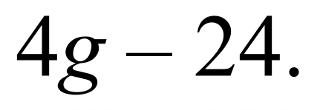

A. 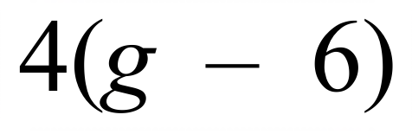 B. 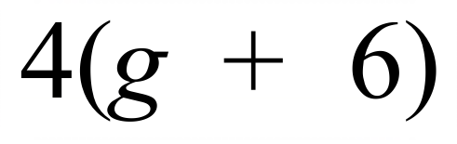 C. 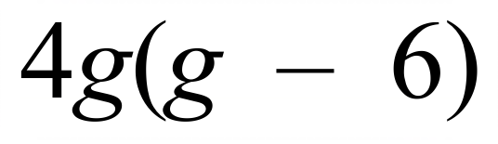 D. 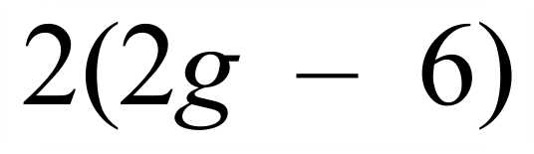
Factorise 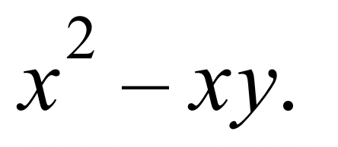

A. 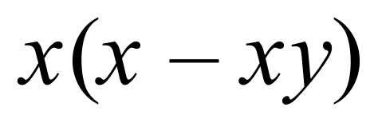 B. 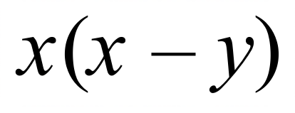 C. 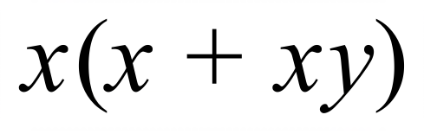 D. 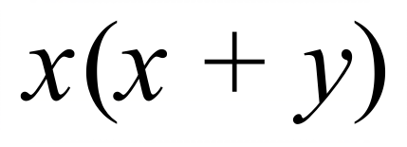
Factorise 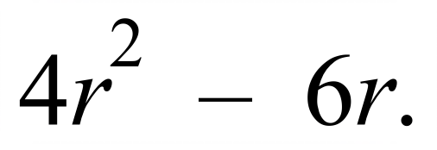
A. 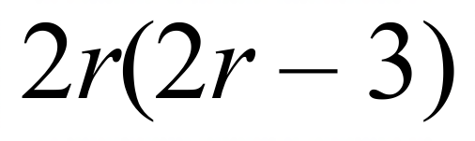 B. 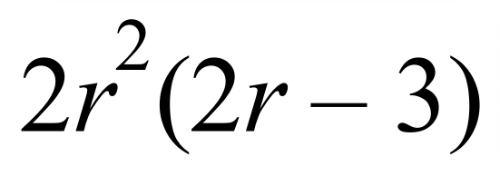 C. 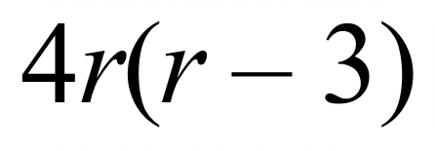 D. 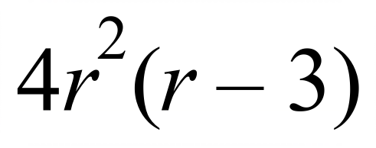
Factorise 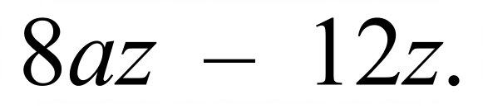

A. 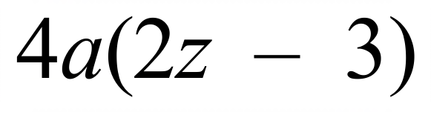 B. 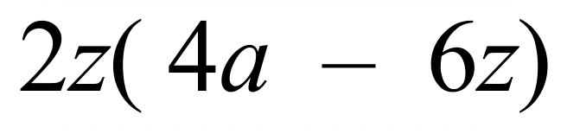 C. 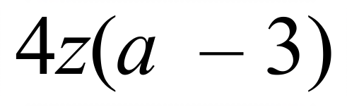 D. 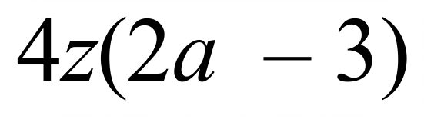
Factorise 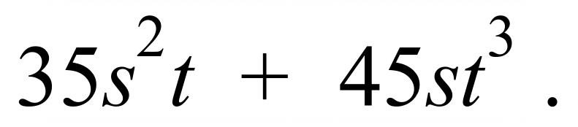

A. 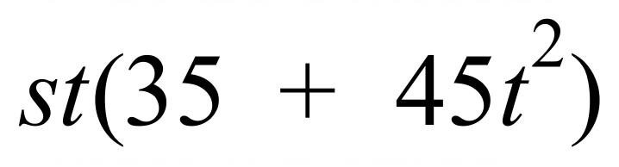 B. 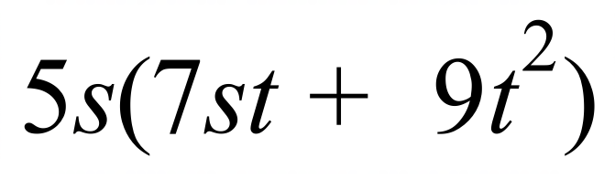
C. 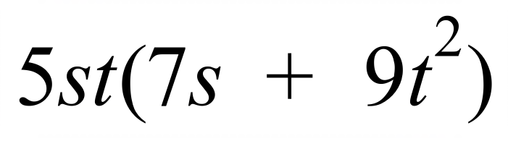 D. 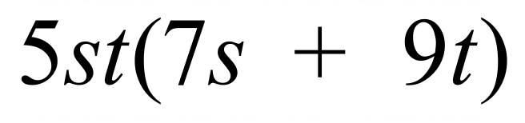
Factorise 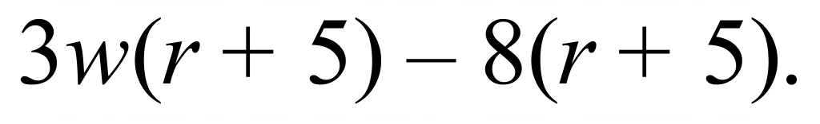

A. 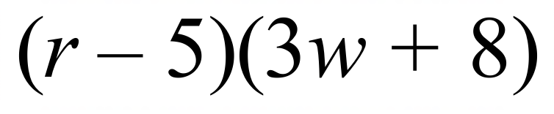 B. 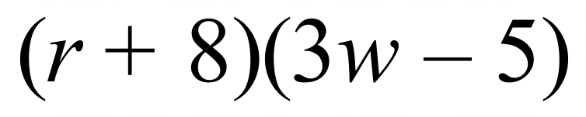
C. 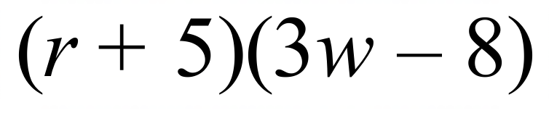 D. 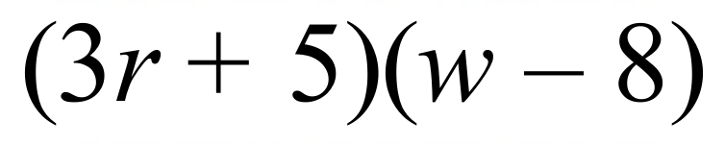
Factorise 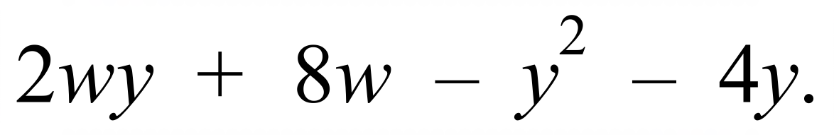

A. 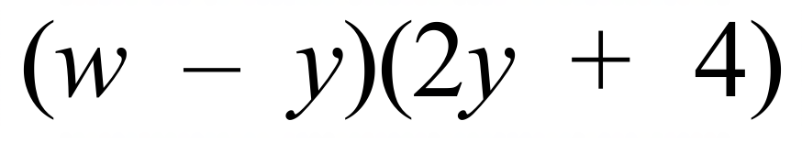 B. 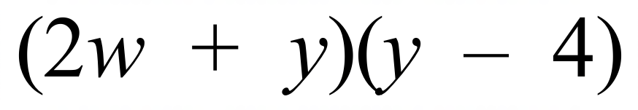
C. 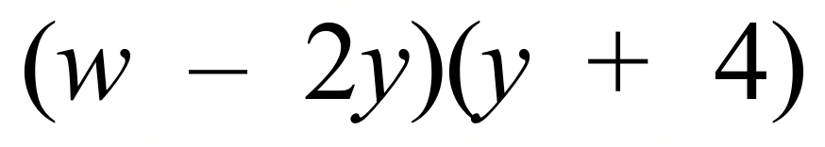 D. 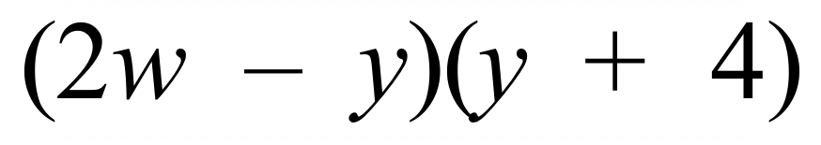
Factorise 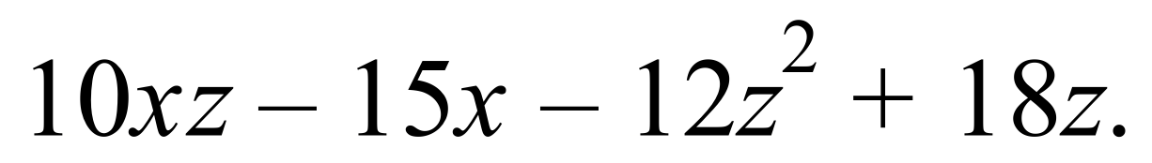

A. 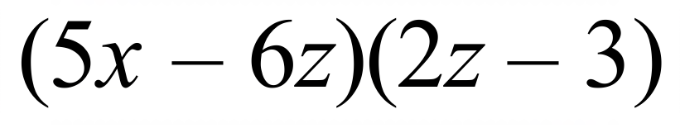 B. 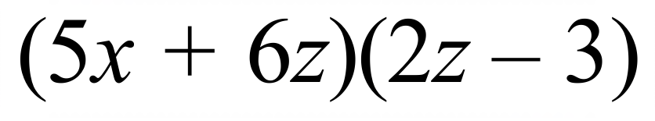
C. 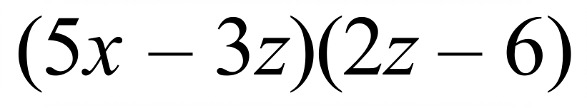 D. 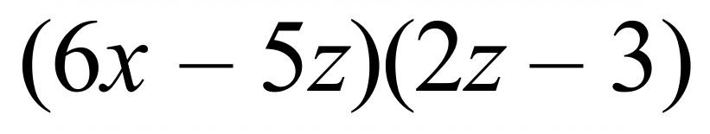
Factorise 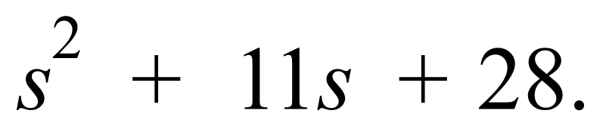

A. 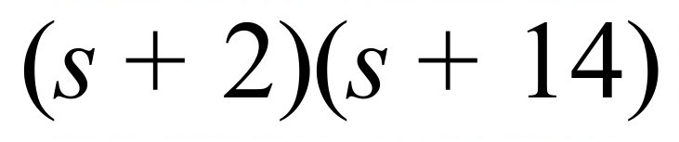 B. 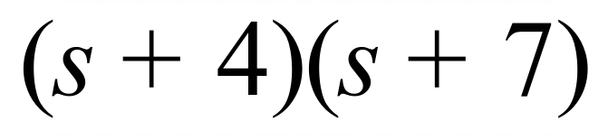
C. 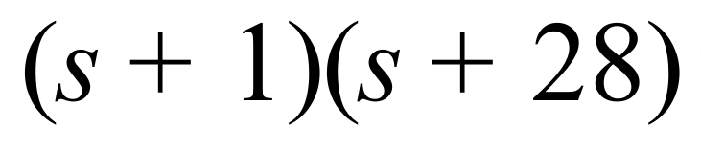 D. 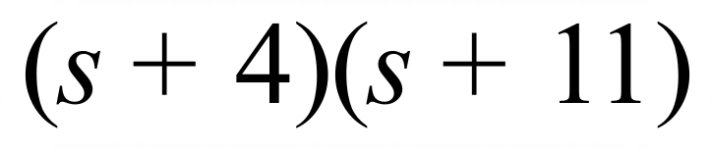
Factorise 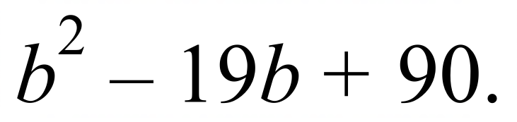

A. 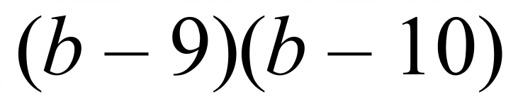 B. 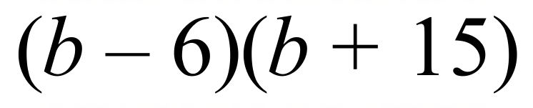
C. 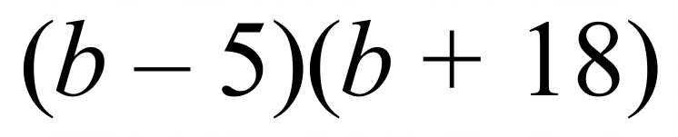 D. 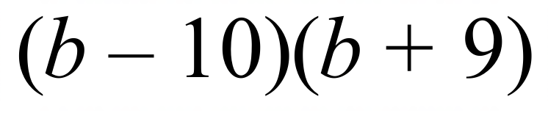
Factorise 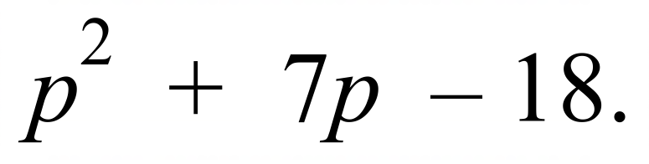

A. 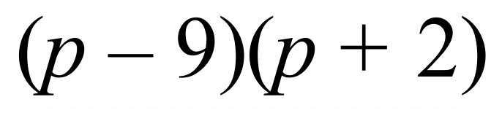 B. 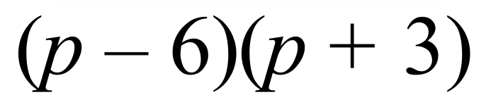
C. 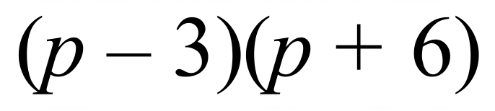 D. 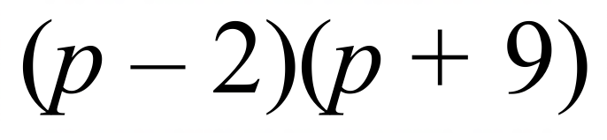
Factorise 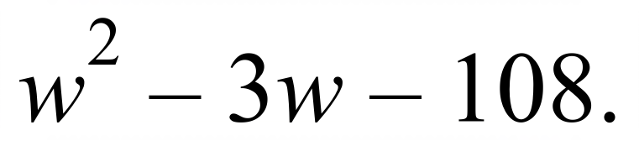

A. 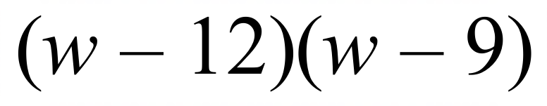 B. 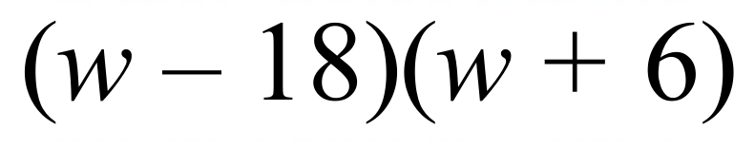
C. 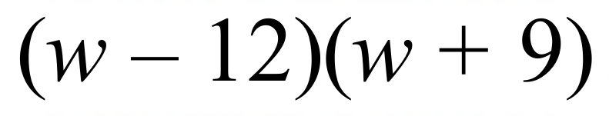 D. 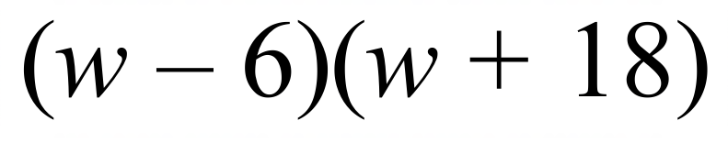
Factorise 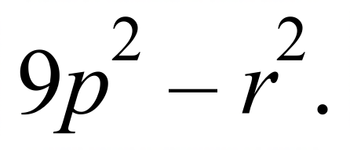

A. 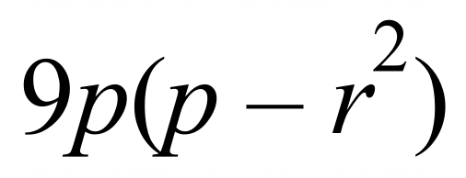 B. 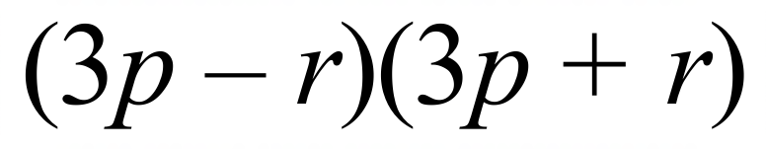
C. 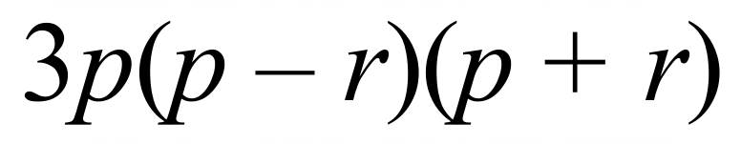 D. 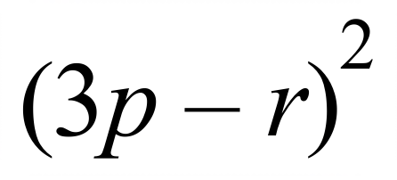
Factorise 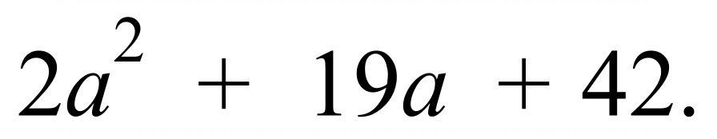

A. 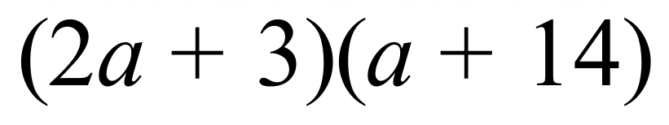 B. 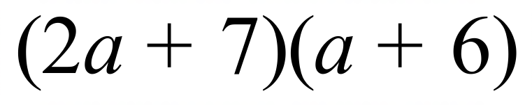
C. 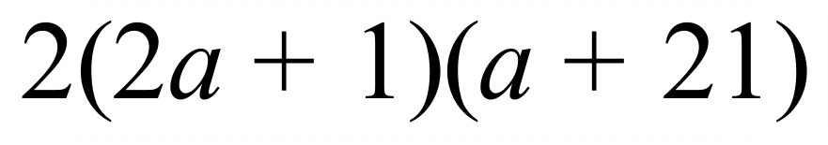 D. 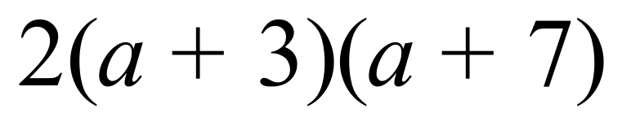
Factorise 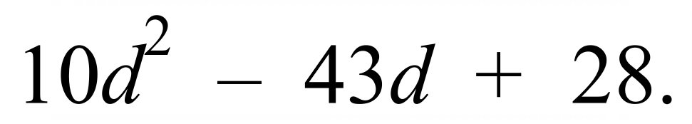

A. 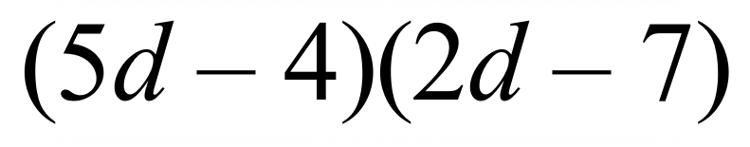 B. 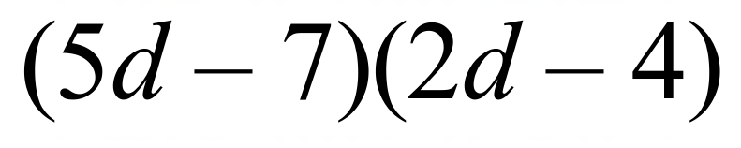
C. 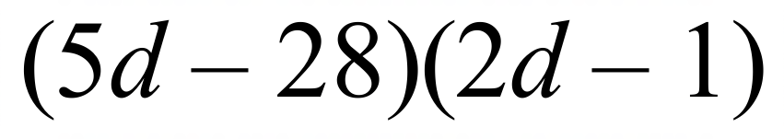 D. 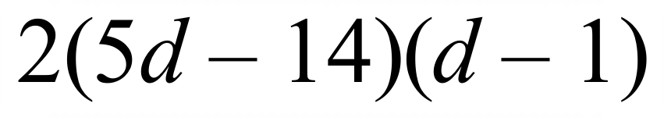
Factorise 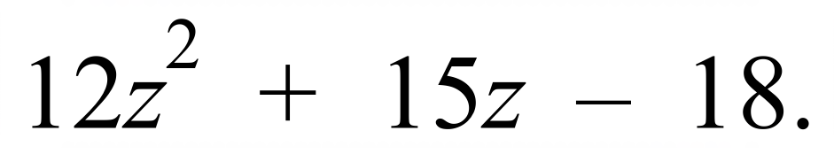

A. 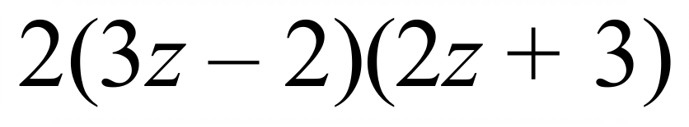 B. 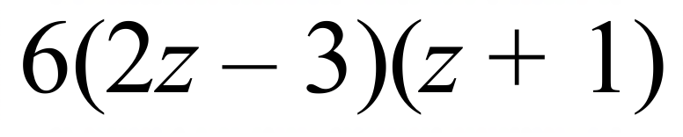
C. 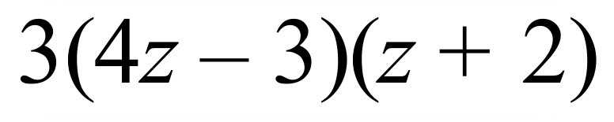 D. 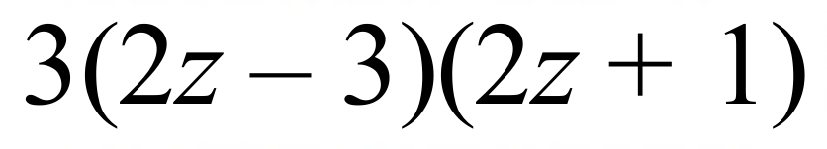

School Name
Mathematics Test 2017
Year 10 | Factorisation | Calculator Allowed
Year 10 | Factorisation | Name___________________
Section 3 Longer Answer Section
Write all working and answers in the spaces provided on this test paper.

 |  | Marks
1. | Simplify the following algebraic fractions, by first factorising.
 | (a) 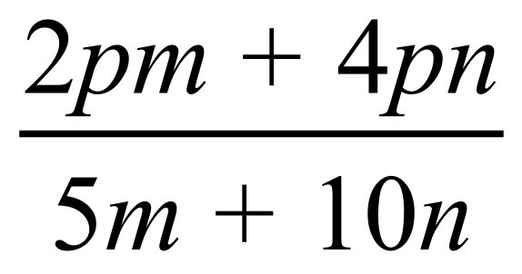  ……………………………………………………………………………………………....  ……………………………………………………………………………………………....  ………………………………………………………………………………………………. | 2
 | (b) 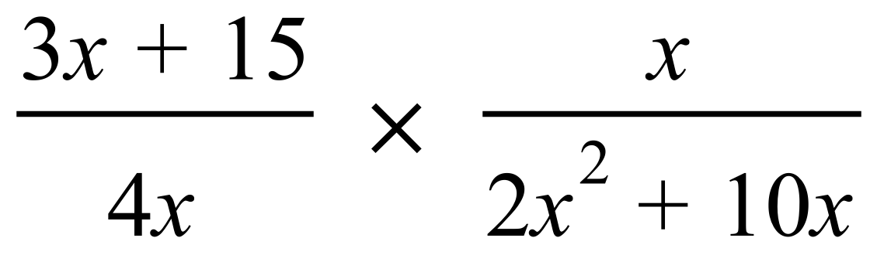  ……………………………………………………………………………………………....  ……………………………………………………………………………………………....  ……………………………………………………………………………………………....  ………………………………………………………………………………………………. | 2
2. | Simplify the following algebraic fractions, by first factorising.
 | (a) 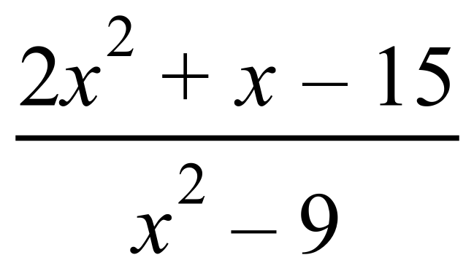  ……………………………………………………………………………………………....  ……………………………………………………………………………………………....  ………………………………………………………………………………………………. | 2
 | (b) 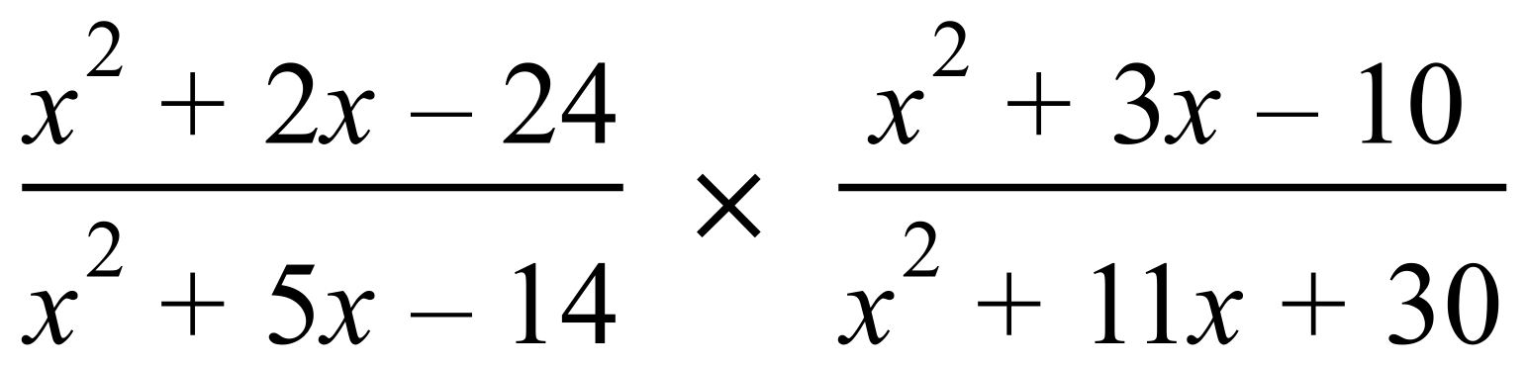  ……………………………………………………………………………………………....  ……………………………………………………………………………………………....  ……………………………………………………………………………………………....  ……………………………………………………………………………………………....  ………………………………………………………………………………………………. | 3
 | (c) 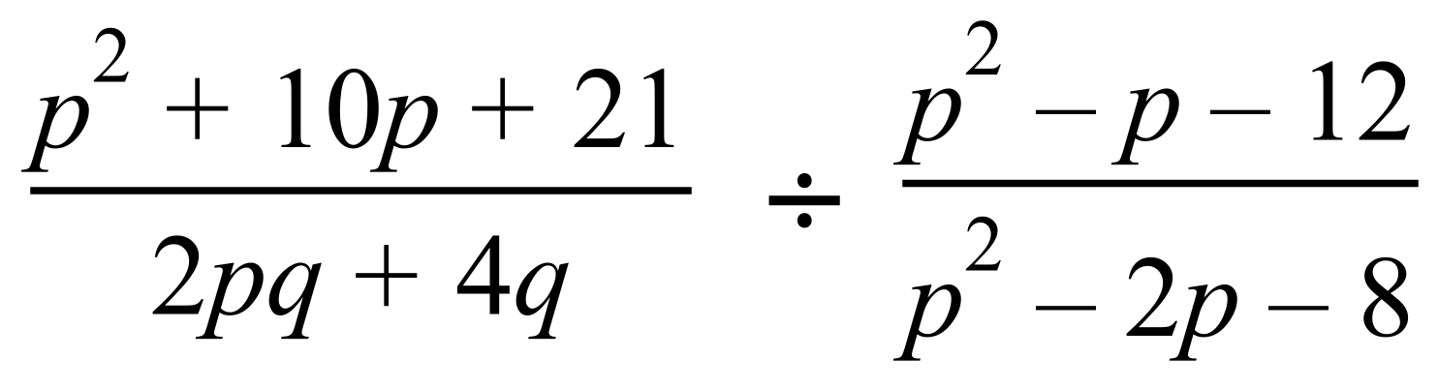  ……………………………………………………………………………………………....  ……………………………………………………………………………………………....  ……………………………………………………………………………………………....  ……………………………………………………………………………………………....  ………………………………………………………………………………………………. | 3

School Name
Mathematics 2017
Multiple Choice Answer Sheet
Factorisation
Name _____________________________________________
Completely fill the response oval representing the most correct answer.
1. A B C D
2. A B C D
3. A B C D
4. A B C D
5. A B C D
6. A B C D
7. A B C D
8. A B C D
9. A B C D
10. A B C D
11. A B C D
12. A B C D
13. A B C D
14. A B C D
15. A B C D
16. A B C D

School Name
Mathematics Test 2017
Year 10 | Factorisation | Non Calculator Section
ANSWERS

Question | Working and Answer
 | 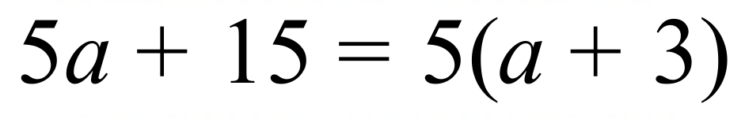
 | 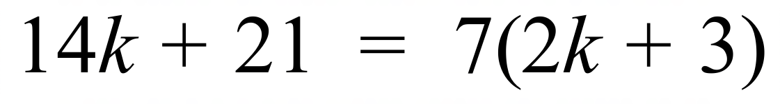
 | 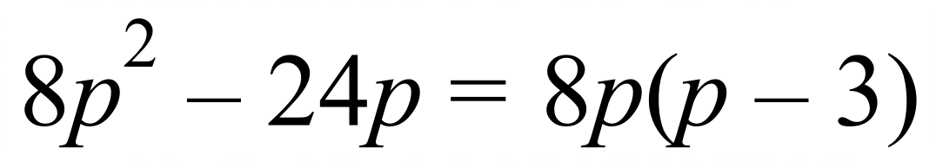
 | 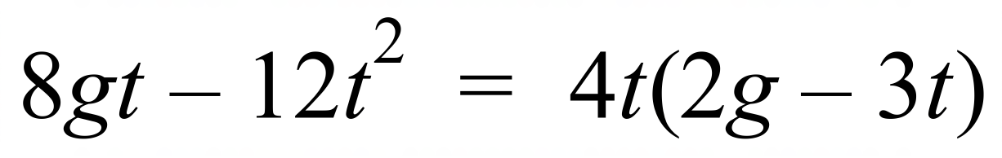
 | 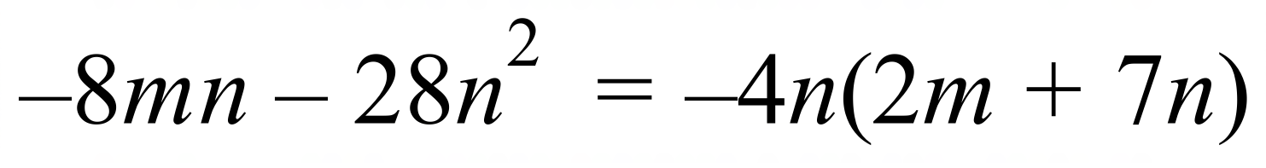
 | 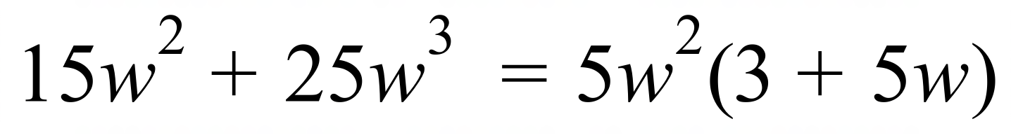
 | 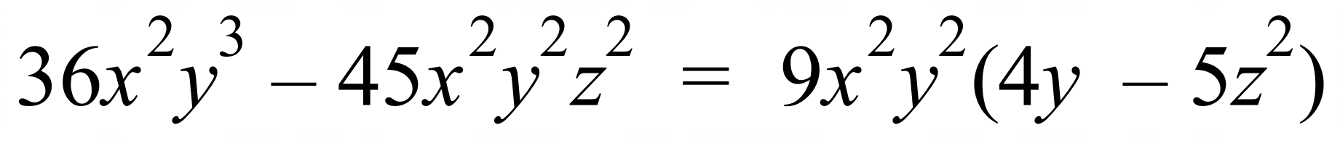
 | 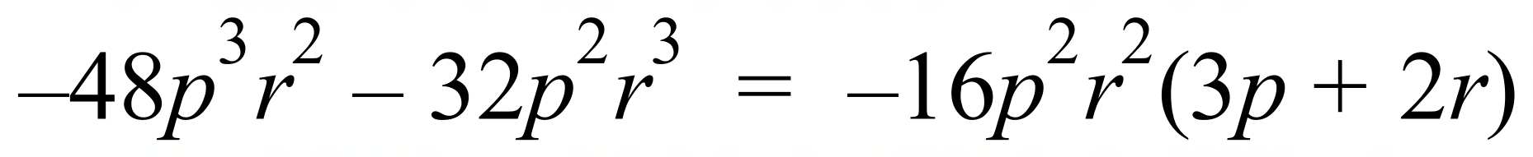
 | 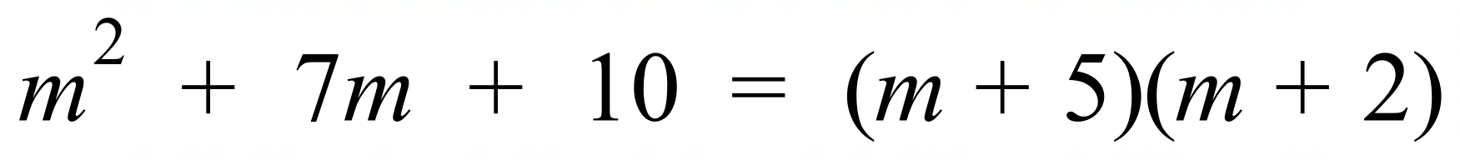
 | 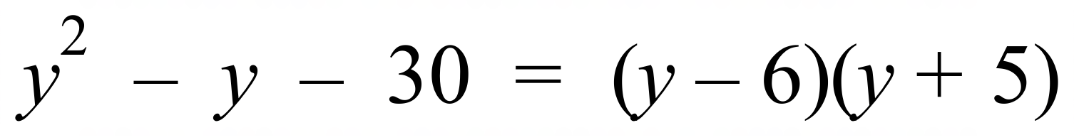
 | 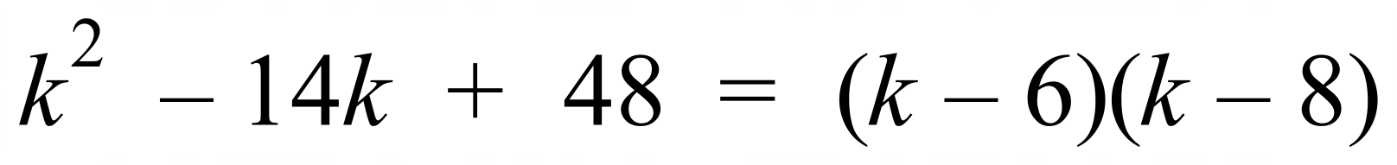
 | 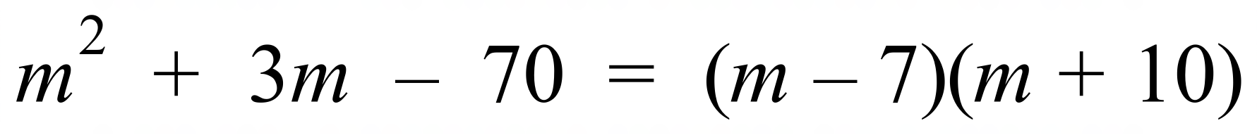
 | 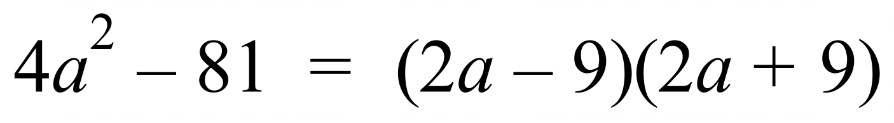
 | 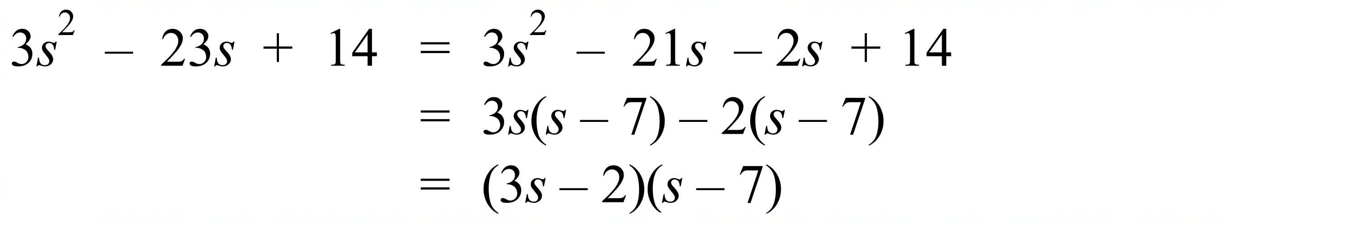
 | 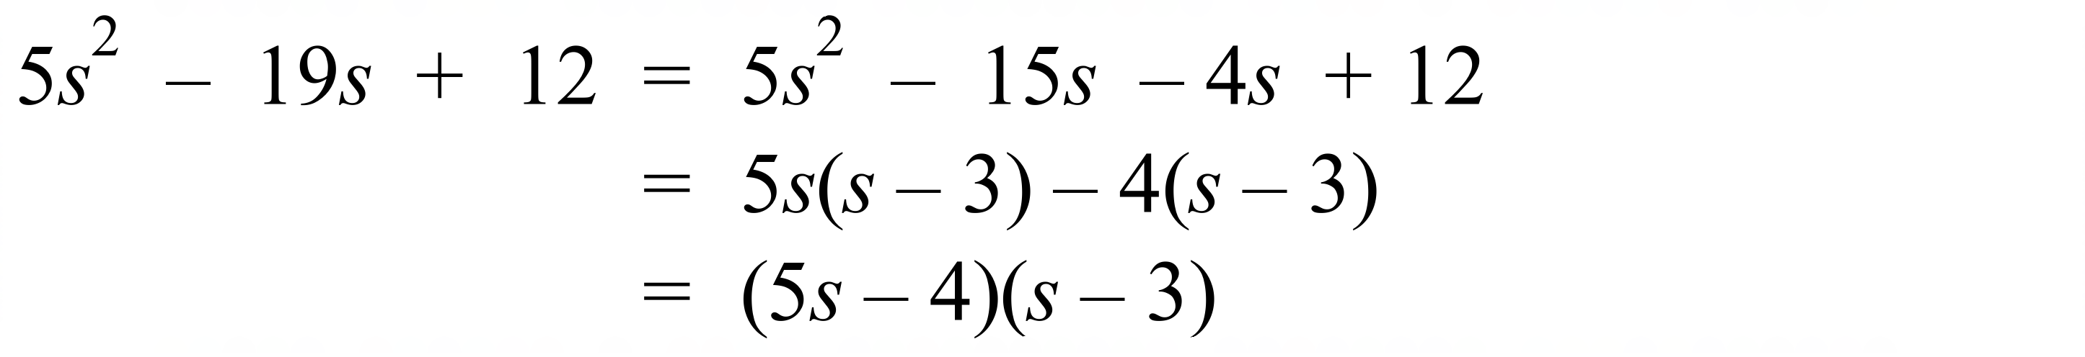
 | 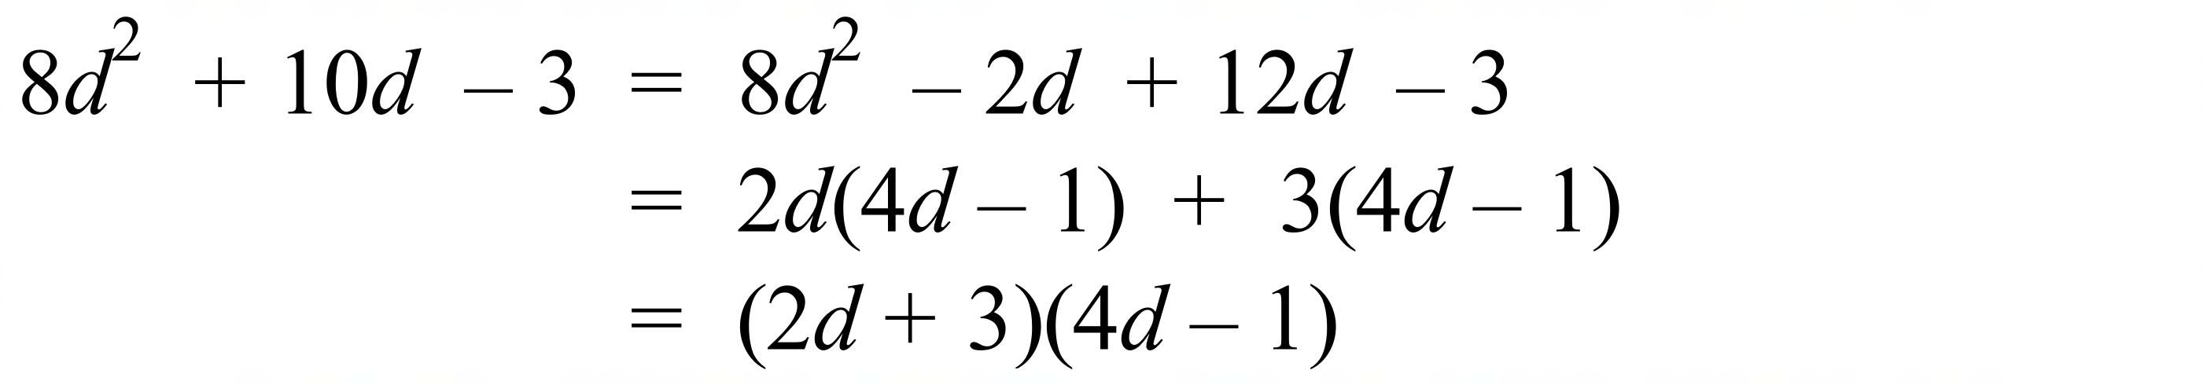
 | 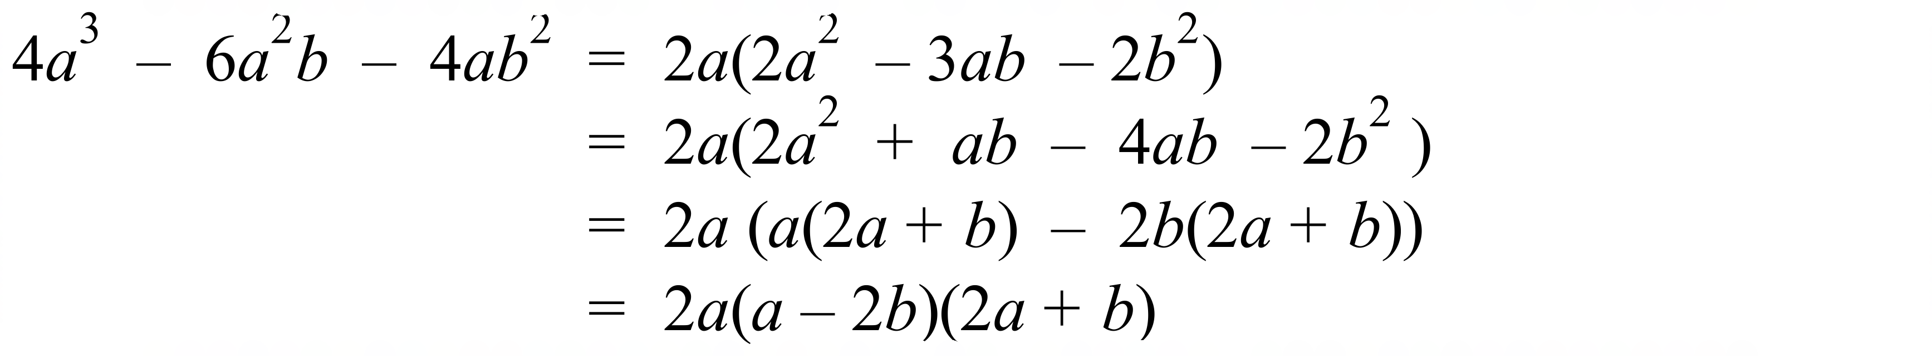

School Name
Mathematics Test 2017
Year 10 | Factorisation | Calculator Allowed  Multiple Choice  Section

ANSWERS

Question | Working | M C Answer
 | 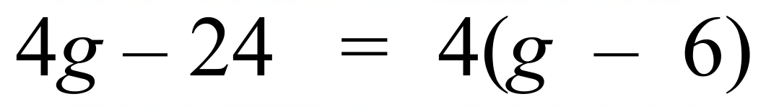 | A
 | 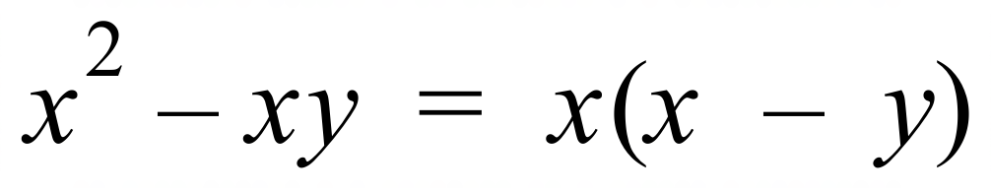 | B
 | 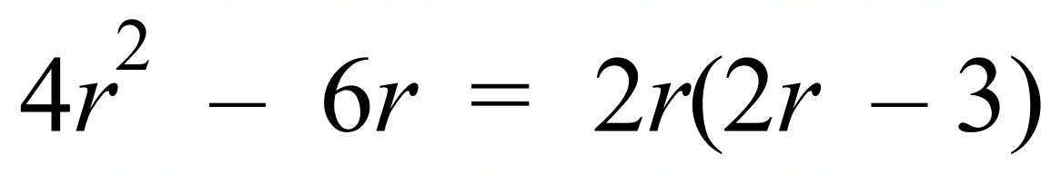 | A
 | 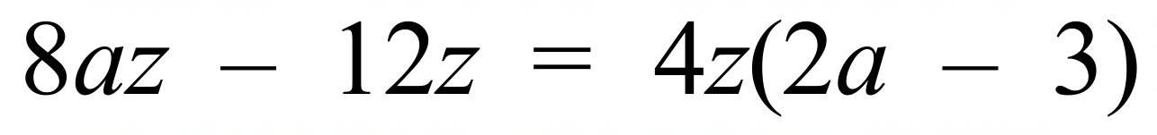 | D
 | 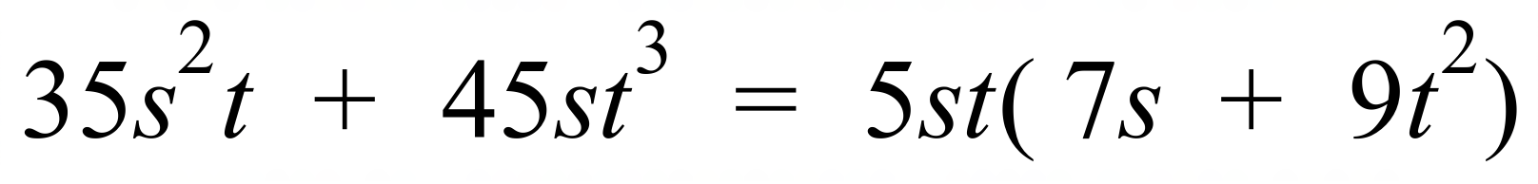 | C
 |  | C
 | 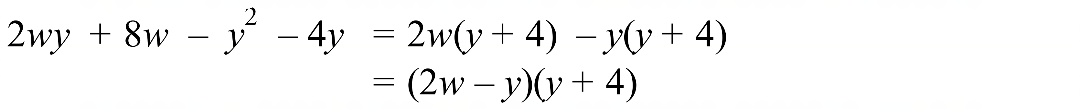 | D
 |  | A
 | 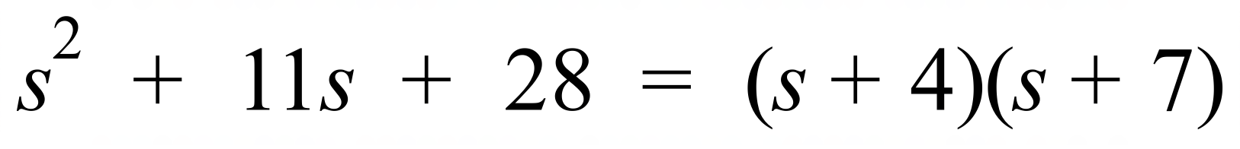 | B
 | 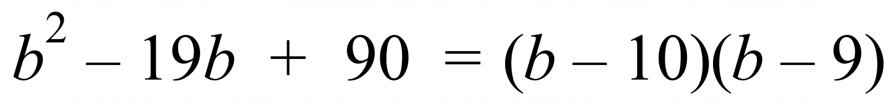 | A
 | 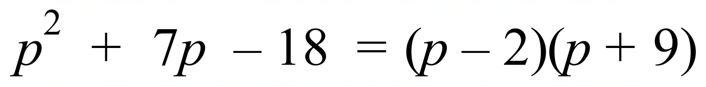 | D
 | 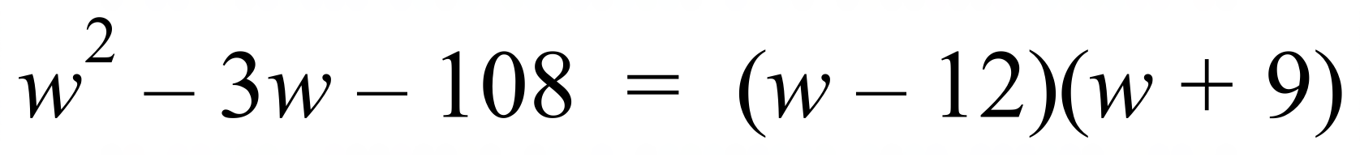 | C
 | 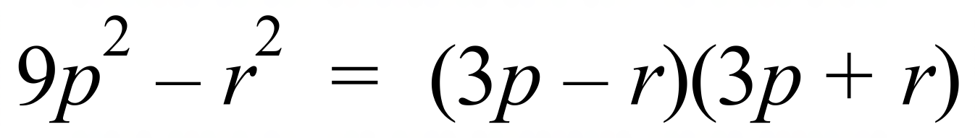 | B
 | 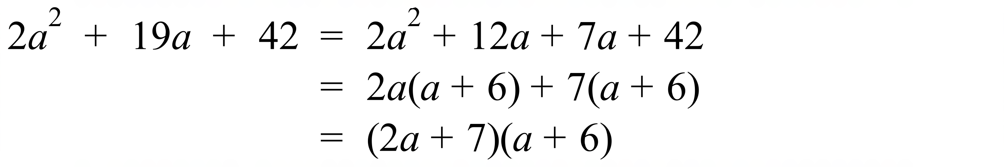 | B
 | 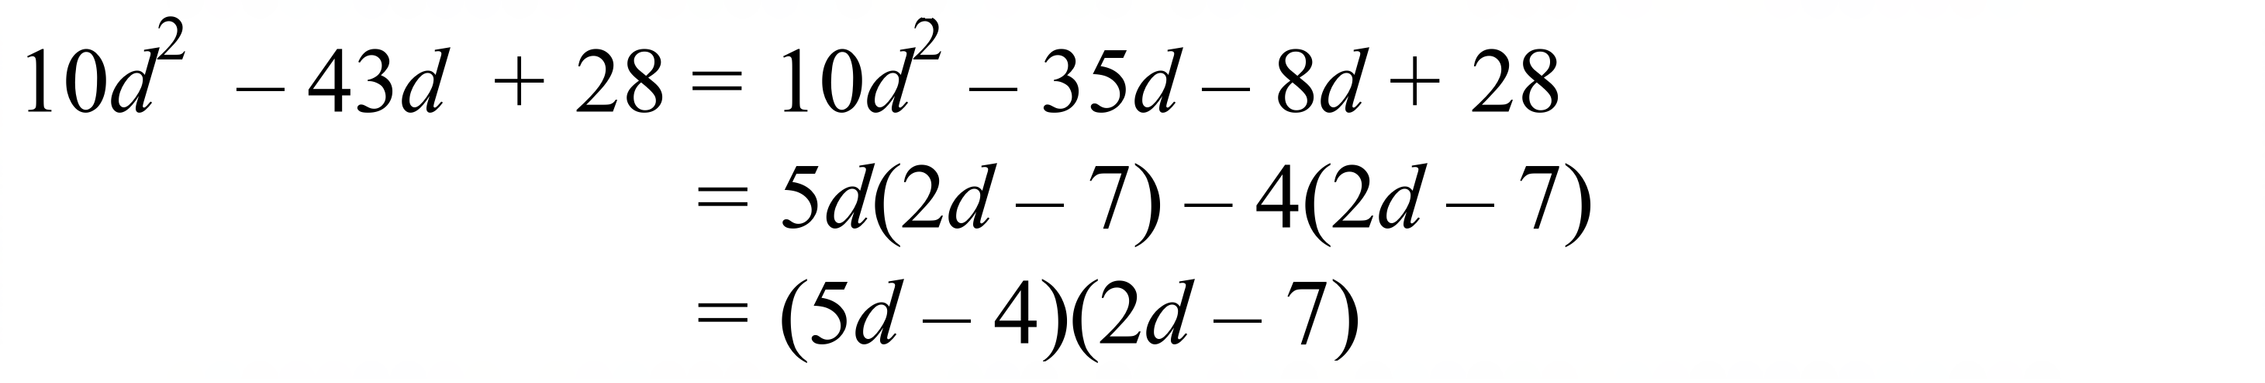 | A
 | 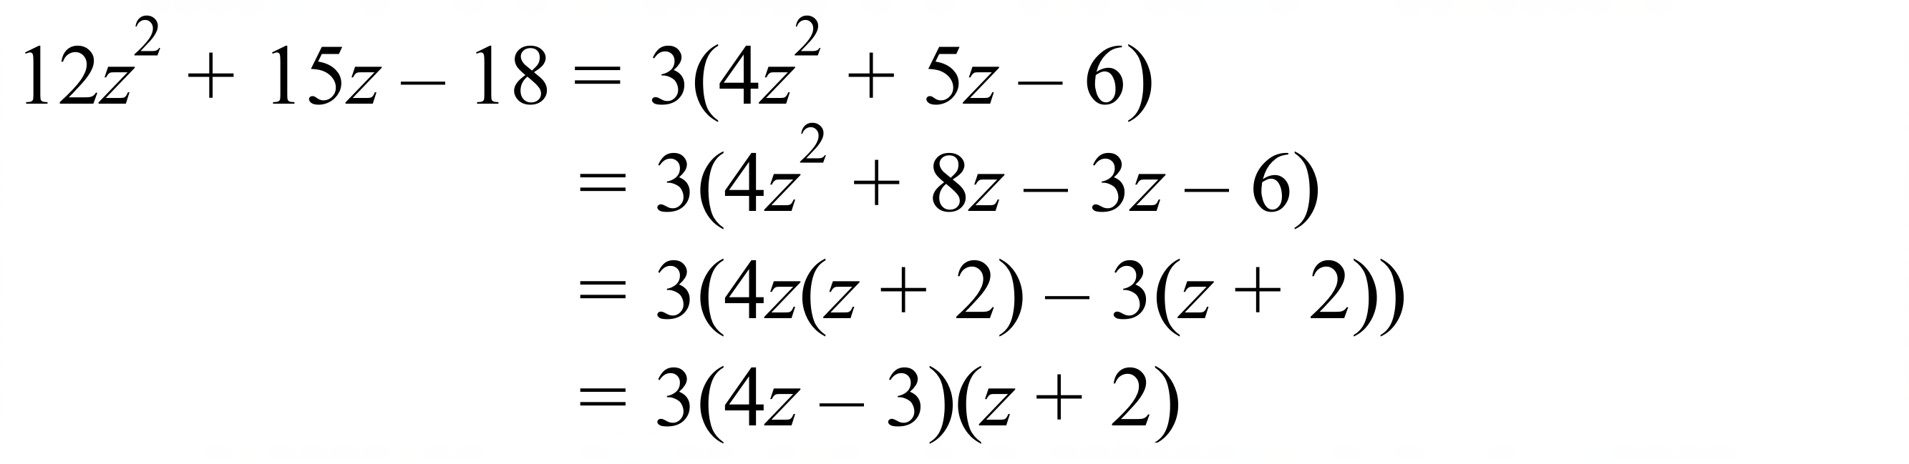 | C

School Name
Mathematics 2017
Multiple Choice Answer Sheet
Factorisation
Name _____________________________________________
Completely fill the response oval representing the most correct answer.
1. A B C D
2. A B C D
3. A B C D
4. A B C D
5. A B C D
6. A B C D
7. A B C D
8. A B C D
9. A B C D
10. A B C D
11. A B C D
12. A B C D
13. A B C D
14. A B C D
15. A B C D
16. A B C D

School Name
Mathematics Test 2017
Year 10 | Factorisation | Calculator Allowed  Longer Answer  Section
ANSWERS
Question | Working and Answer | Marks
1. | (a) 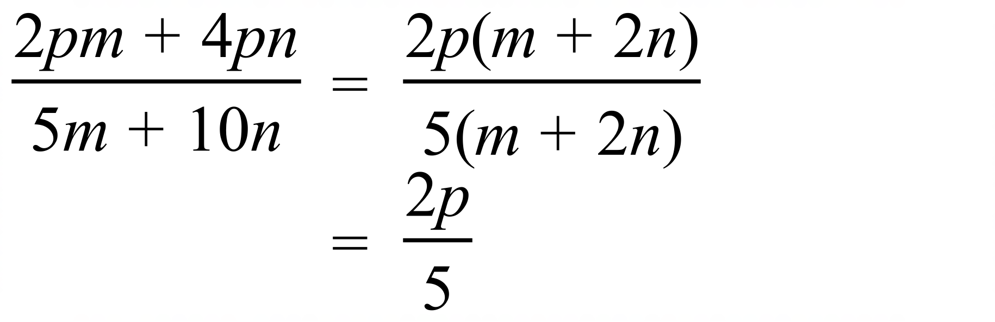 | 2 marks for correct answer  1 mark for answer with some correct factorisation or cancellation
 | (b) 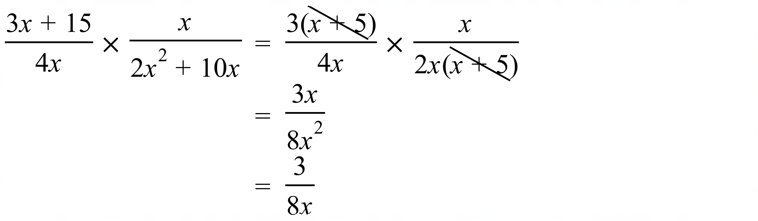 | 2 marks for correct answer  1 mark for answer with some correct factorisation or cancellation
2. | (a) 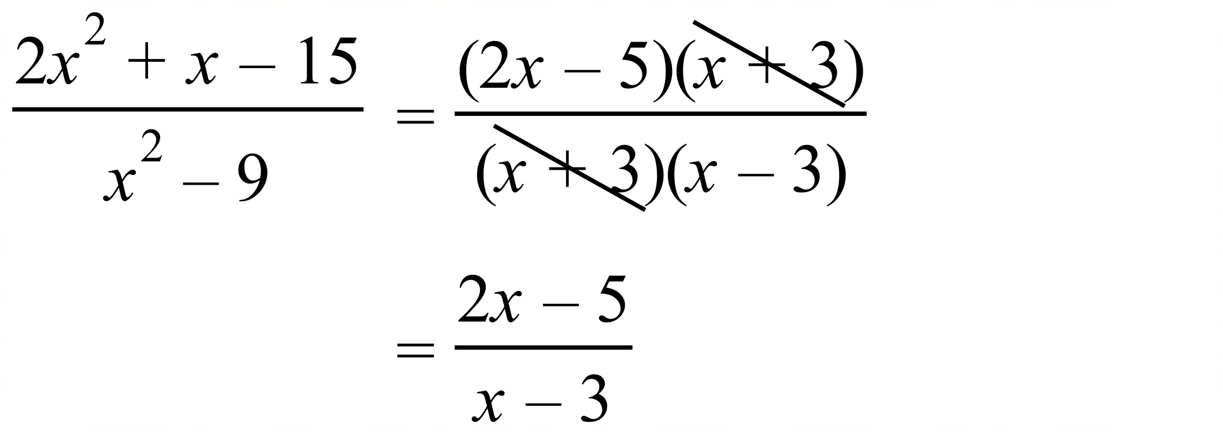 | 2 marks for correct answer  1 mark for answer with some correct factorisation or cancellation
 | (b) 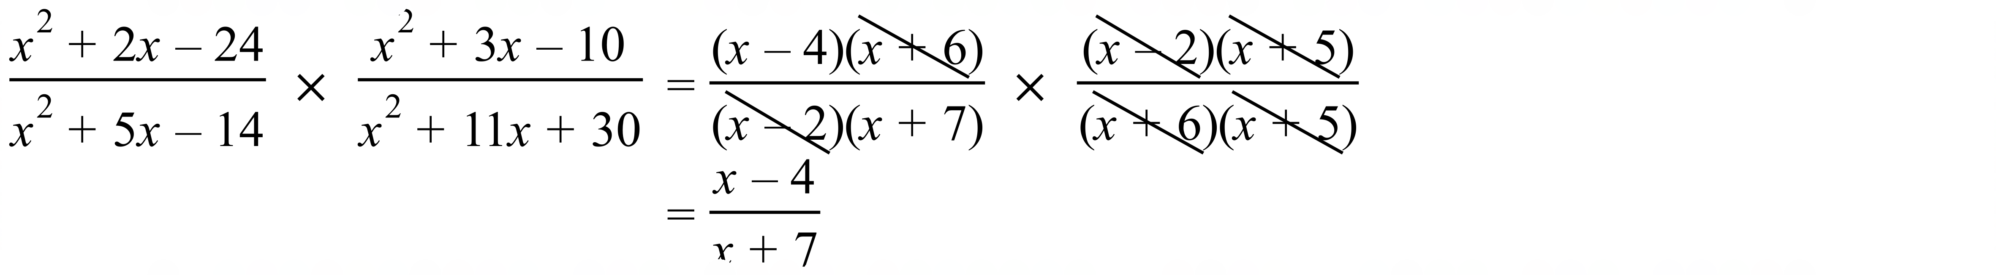 | 3 marks for correct answer  2 marks for otherwise correct answer with minor error  1 mark for answer with some correct factorisation or cancellation
 | (c)  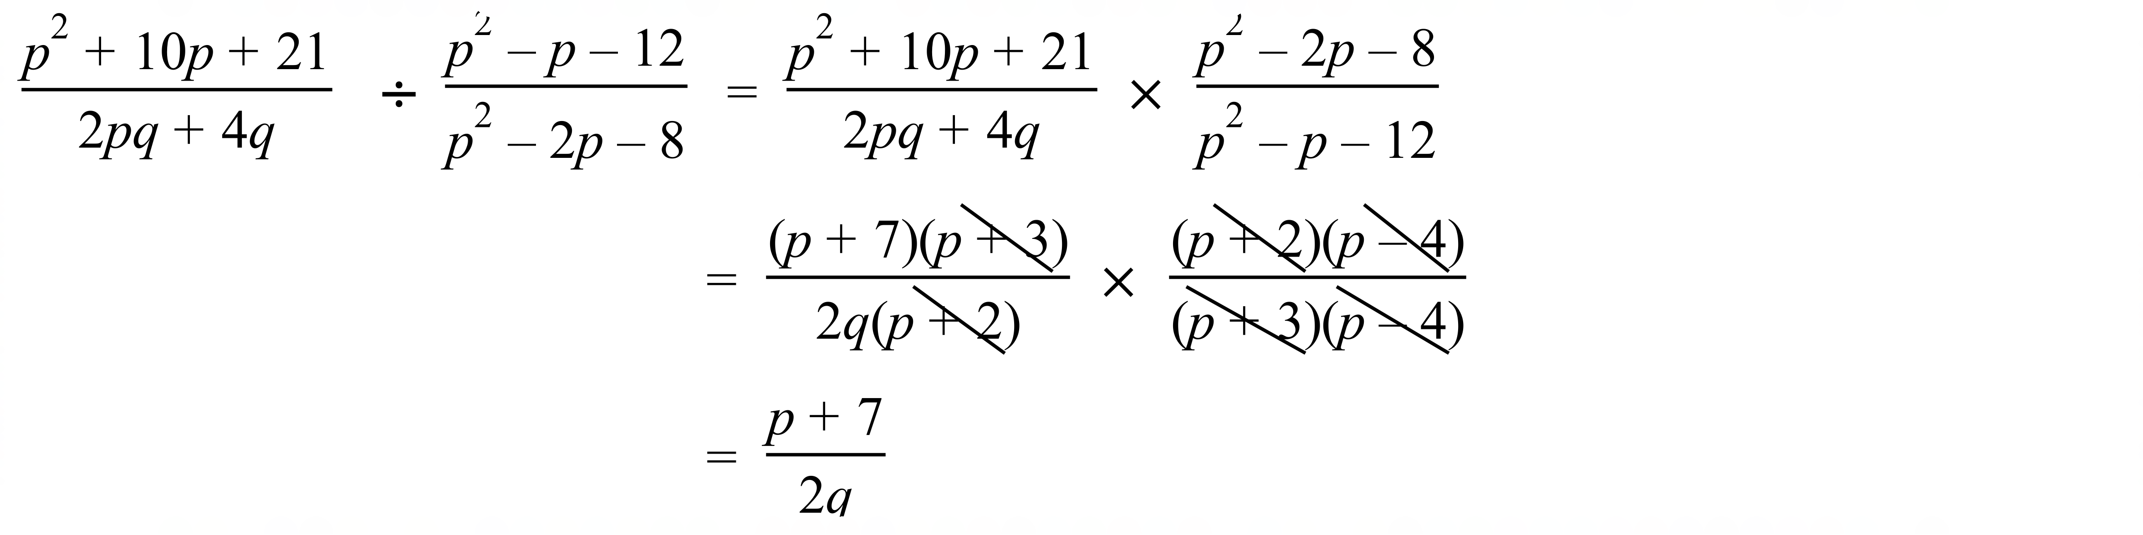 | 3 marks for correct answer  2 marks for otherwise correct answer with minor error  1 mark for answer with some correct factorisation or cancellation

